HOME SECURITY
(ABSTRACT)
Why Home Security?
Today in this competitive world, security is one of the major concerns. We always need privacy and security for our valuable things, either it is your family or some confidential and important documents. You sometimes leave your valuable things in some place because you cannot stay at that place all the time and keep an eye on that to protect it. So we need a security master that will help us in taking care of our private and valuable things in our absence. Home Security is one of that security masters that will not let you and your family unsecured. It will protect your family and your important document and property from theft and illegal access by keeping an eye on them.
What is Home Security?
Home security is a web application that will connect to a installed camera (a place where you need protection) through a core application. You can thus monitor the place through the web application anywhere where you can access internet. The core application will run on a computer connected to that camera. You can control the camera and its features either through the web application(website) or through the core application. The installed camera can trigger various events in case of detection. The detection means when there is a motion in front of camera it will trigger events as the services enabled by the user.

Requirements for Home Security:
- A Computer having an internet connection.
- A digital camera connected with the computer.
- Java Virtual Environment (JDK & JRE)
- Open CV 3.0.0
- Access to Internet for registration purpose and controlling through web application.

Home Security Web Application view:
(Front Page)
(Login page)
(Signup Page)
(Services Page)

Home Security Core Application view:

Features of Home Security:
- One Can access the settings of camera from any part of the world through internet.
- You can start the detection mode from the core desktop application or from the web application.
- The detection mode triggers various events in case of any motion.
- You can get alerts when there is motion in front of camera.
- View the captured images online through web application.
- Register mobile numbers on which you want to get alerts during detection.

Working of Home Security:
You have to register yourself on the web application for getting a username and password. After getting the username and password you can download the core application setup file from the website. After downloading the core application from the website launch it by double clicking on it. A window will open up which will ask your username and password. Enter your username and password to start the camera and other monitoring services. The detection mode then can be enabled by the website. 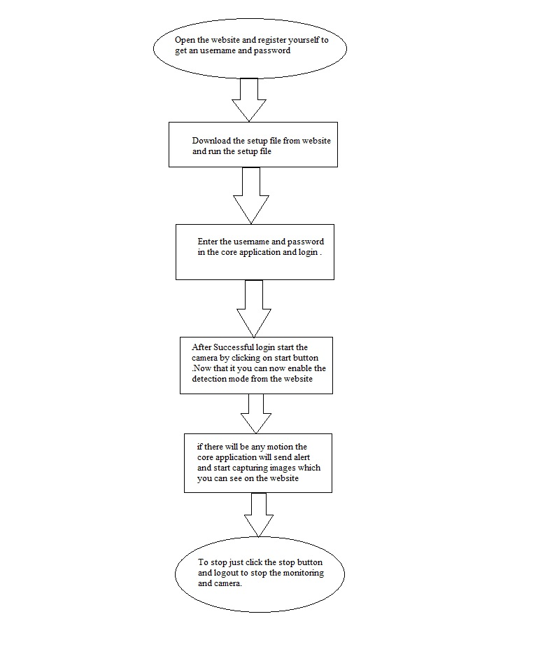
When there will be any motion during detection mode it will capture images and will store it on the web server where you can view all detected images with date and time though the website by just logging into your account. Also during detection, you will get an alert that there is an illegal activity with the date and time of detection in the message.

Additional Setting and Software for Home Security Core Desktop Application:
- Install Open CV 3.0.0 which can be downloaded from github website.
- Set the path of open CV in the System Environment Variable where you have installed the Open CV as (installed directory/build/x64 or x86/vc11 or vc12/bin).
- Install Java Development Kit.

Conclusion:
Home Security is a hybrid web application that will monitor and detect images in case of any motion detected. It will send alert to your registered mobile number and upload the detected images on to the web server which can be viewed on the web application. So Home Security is one of the powerful application that will help in detecting theft and restrict it by happening. It will not only decrease the theft rate but also help in gathering theft information.
Thus Home Security is a must having application for every home and office so that you and your family can have a better sleep and better future for tomorrow.

